Pre-diabetes & Metabolic Advice Information | Priory GP  Practice CIC | 

We have developed this information for our patients with pre-diabetes along with other related conditions such as:
- non-alcohol fatty liver disease (NAFLD or fatty liver),
- polycystic ovary syndrome (PCOS),
- previous gestational diabetes (GDM),
- or gout.
These conditions all come under the umbrella of metabolic conditions and often people can have more than one of them. This document will refer to pre-diabetes, but the information is applicable to fatty liver, PCOS, previous GDM and those at risk. There are also benefits for people without any of these conditions, but who have high blood pressure (hypertension).

What happens in pre-diabetes/fatty liver and other metabolic conditions?
Pre-diabetes is a condition where the blood sugar levels are above normal and heading towards the levels seen in people with Type 2 diabetes (T2DM). T2DM accounts for 90% of all diabetes. It is different from type 1 diabetes, which is an autoimmune condition in which the body destroys the islet cells, which are responsible for insulin production.  T2DM is a gradual process, often developing over many years, where the blood sugar, or glucose, levels will slowly rise. The body produces insulin in response to raised blood sugar levels. Insulin is like the key to unlock the cells to allow the glucose in the blood to move into the cells (Figure 1). | 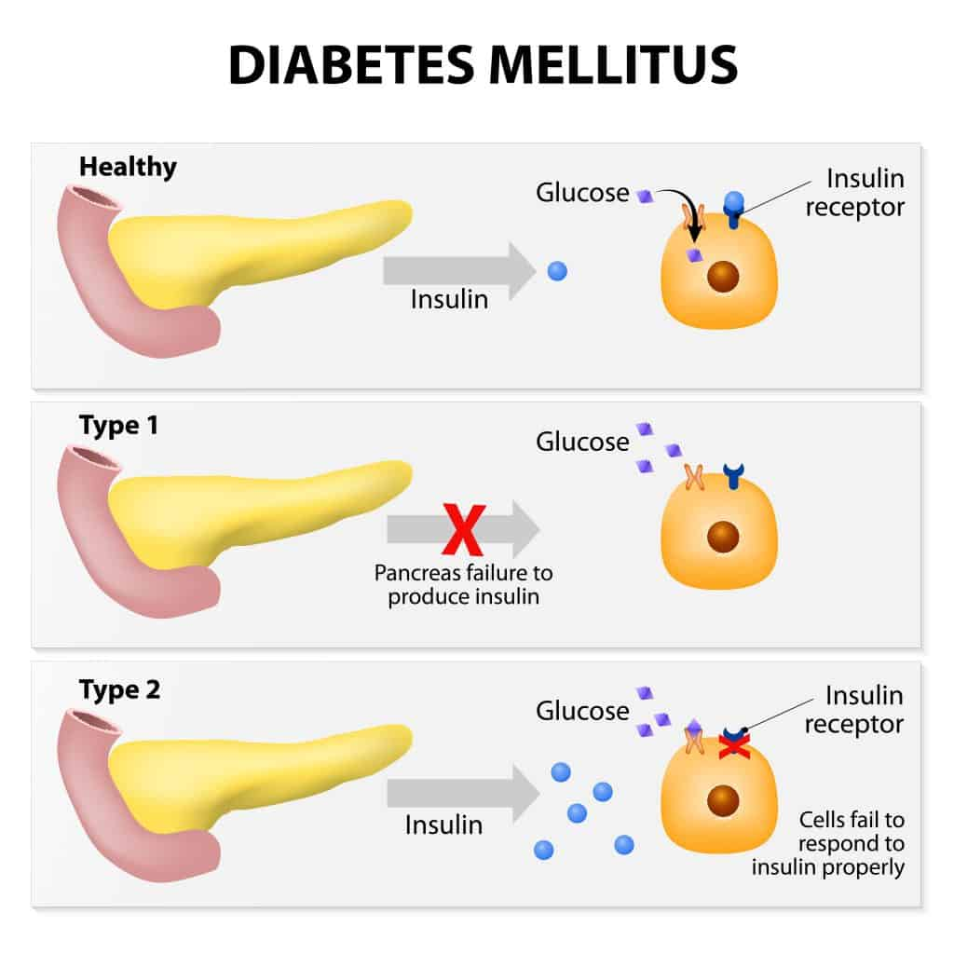  Figure 1: Diagram showing what happens in type 1 & diabetes
In pre-diabetes and T2DM, the body becomes more resistant to the insulin, often from carrying additional weight, particularly around the tummy/abdominal area, meaning that more insulin is needed to do the same job, like 2 keys being needed to unlock the cells instead of one. The body will be able to compensate for a time by producing more and more insulin and by also trying to flush out extra sugar by making you feel thirsty and drink more. The body is very good at storing fat and will store some around the organs in the tummy or abdominal area. This is called visceral fat and can cause more health issues than the weight being carried elsewhere on the body.
The body will store fat in the liver and over time this can make the liver very fatty, leading to the condition fatty liver. Fatty liver is diagnosed based on blood tests, taking information from the person and an ultrasound scan can be performed to view the liver and look for the fatty infiltration. There are no medications for fatty liver, the treatment is diet and lifestyle changes with weight loss.

How is pre-diabetes diagnosed?
Pre-diabetes and T2DM are diagnosed from blood tests. People do not always have symptoms. The most common test is called a HbA1c and this gives us an average of a person’s blood sugar levels over the last 3 months. To confirm pre-diabetes you need two tests with the HbA1c result at 42-47. For diabetes the result is 48 or above. Usually, these two tests will be at least 1 month apart. HbA1c results at 39-41 are in the normal range, but at the top end of this range and at risk of progressing to pre-diabetes. Therefore, you may have been given this information leaflet.

Why is it important?
Pre-diabetes is like a waiting room for T2DM. We know that if no changes are made to a person’s diet and lifestyle, then around 70% will go on to develop T2DM in the coming years. There are no medications for pre-diabetes, but it is an important diagnosis. because it is a warning that a person is at high risk of progressing to T2DM. Once you have had 2 tests to confirm pre-diabetes you will need a minimum of annual blood tests to ensure your condition has not progressed. Some people are diagnosed with T2DM without going through the pre-diabetes stage, missing the chance to prevent it.
As we know pre-diabetes and T2DM can lead to many other health issues. Once you have a pre-diabetes diagnosis you should be monitored not only for the pre-diabetes, but for your blood pressure, your cholesterol or lipids, your kidneys and your liver. Although there are no medications for pre-diabetes, you may often need to take additional medications to keep other conditions well controlled. You should attend at least once a year to the treatment room for blood pressure, weight, blood and urine tests and then your results will be reviewed by our team. Some people need to be monitored more often. People with pre-diabetes are managed at the surgery by our practice nurse Jane or by our advanced nurse practitioner, Katie Brown.

Is it possible to ‘reverse’ pre-diabetes and T2DM?
Yes, it is possible to ‘reverse’ pre-diabetes and T2DM. We would actively encourage a ‘diabetes detour’. Having pre-diabetes does not have to mean it is inevitable that you will go on to develop T2DM. The sooner action is taken, the easier it is to reverse it. Pre-diabetes would be considered ‘reversed’ if the blood test, HbA1c drops back to 41 or below for 2 readings at least 3 months apart, which is the ultimate goal in pre-diabetes.
Weight loss can improve pre-diabetes and other metabolic conditions, with just a 5% weight reduction showing better pre-diabetes control. Diet plays a larger role in weight loss (approx. 80%) than exercise (approx. 20%). This is encouraging as not everyone can exercise. However, exercise doesn't require a gym membership; even short walks can significantly enhance overall health and mental well-being, especially if done outdoors.

If you do go on to develop T2DM, there are medication options for this condition. Medications for T2DM are very helpful; however, diet and lifestyle changes can often provide impressive improvements in diabetes control, in some cases with people being able to put their T2DM into remission (Figure 2). Type 2 diabetes remission has only been a concept for around the last 10 years, as it was always thought to be a progressive condition. | 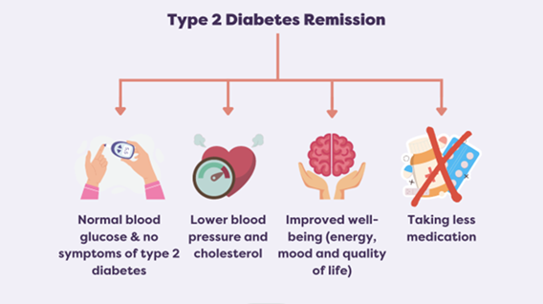
 | Figure 2: T2DM remission

Indeed, if no changes are made to diet and lifestyle then the condition will progress and over time the number of medications required will increase, often to 3 or 4 different types and the average person requiring insulin by injection within around 10 years.

What about weight loss injections?
Many people are interested in weight loss injections (GLP1s). However, these are not available for weight loss on the NHS in NI due to a lack of specialist clinics. While helpful, trials show weight loss includes fat, muscle, and bone mass. Loss of muscle and bone is concerning, and when medication stops, two-thirds of the weight returns, with this weight being largely as fat, not the lost muscle or bone mass. This indicates the importance of addressing eating and lifestyle behaviours, rather than just symptoms. There is growing evidence to suggest that there is a condition called food addiction. More information can be found on the Public Health Collaboration’s website.

What can I do to help my pre-diabetes?
We now have more and more trials and information to show that pre-diabetes can be helped if we reduce the amount of carbohydrates coming into the body. We have always known sugary foods and drinks are something the pre-diabetic and T2DM body will struggle to manage, but we also now know that it is also the carbohydrates - as these will be broken down into sugar, like the sugary foods and drinks. The practice has been working with a charity to run a programme which supports patients with pre-diabetes, T2DM, and other metabolic conditions, to make changes to their diet and lifestyle to improve their metabolic health conditions. This is called a Real Food/Low Carb way of eating.

The participants on our courses have reduced their medications for diabetes, blood pressure, cholesterol (lipids), heartburn, painkillers and gout. Here are their average results:
- Diabetes improvement: HbA1c average reduction: 14mmol/mol, range of 3-31, for those with diabetes.
- Weight reduction: Average loss of 4.7kg or 5.7% of total weight. Range 2-11.5% and 1.4-11kg.
- Liver blood test: GGT (often a marker of fatty liver) reduction of 47.5% or 41 U/L.
- Mental health: Improvement in scoring of mood/anxiety on average of 48% and increased feelings of being better able to manage in 92% of participants.

Making changes to your way of eating is never easy and this is especially difficult when the rest of society is eating in another way, which is seen as the norm. This is compounded by often a lifetime or many years of eating a particular way. However, the important thing is to take it at your own pace and see it as a new way of eating, not a diet. Pre-diabetes does not develop overnight and changing your way of eating can take time to ensure you are doing it consistently. The participants who have been the most successful and managed to maintain their new way of eating on completion of the course, are the ones who have accepted it as a new way of eating and not a diet.

Where can I find more information?
The practice’s real food group is running around twice yearly at the moment and lasts 10-weeks. If you are interested in taking part, there are application forms at both surgeries and planned to go on the website – please complete the form and return the paper copy to the surgery to be passed onto Katie Brown. However, you can go ahead and decide to change your way of eating and lifestyle via the resources below. The course we follow is available for free for people to access and implement at their own pace. If you choose to go ahead with this yourself, we would encourage you to link in with the online support groups, such as the ones listed below.

Useful links:
 | - Public Health Collaboration (PHC):  Charity who support a real food/low carb approach and provide support to the practice’s courses.  https://phcuk.org/
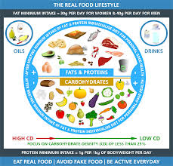 | - Link to the PHC course:  A free 8-week course available on YouTube.  https://www.youtube.com/watch?v=Ll1OFEPfBCI
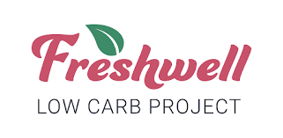   | - Freshwell Low Carb:  This was set up by 2 UK GPs in England to provide information to their patients and has expanded since then, including apps and Facebook support group  https://lowcarbfreshwell.com/
  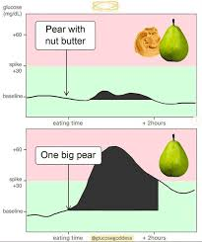 | - Glucose Goddess:  Jessie Inchauspé, also known as the Glucose Goddess, is a French biochemist who has tips on reducing glucose spikes, showing real world data from glucose sensors.  https://www.glucosegoddess.com/en-gb
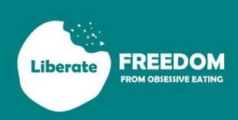 | - Liberate:  Liberate is an 8-week educational course with weekly support for the following 12 months. It was designed for those feeling addicted to ultra processed foods, using the biopsychosocial model of health.  https://liberatetoday.org/
Online support groups:
 | - PHC Real Food Lifestyle Support Group on Facebook  - Freshwell Low Carb Support Group on Facebook

CAUTION: Medications to be cautious of if starting a real food/low carb approach?
If you are taking a medication called an SGLT2i, such as: Canagliflozin, Empagliflozin or Dapagliflozin, these medications need to be paused for the first 4 weeks after commencing a real food/low carb way of eating.

If you are taking a medication for your blood pressure or heart. You would need to obtain a home blood pressure monitor (from Amazon or a local pharmacy) and check your blood pressure on a twice daily (before breakfast and before evening meal) basis during the course. This is based on previous participants who have required their medication for blood pressure to be reduced or stopped completely all due to their diet and lifestyle changes. You would need to contact us if your blood pressure top reading (systolic) was consistently less than 115mmHg, as a general rule of thumb for most people taking BP medications. If you are under the Cardiology or heart failure teams, your blood may run lower than this.

If you are unsure or have any queries, arrange an appointment with Katie Brown, advanced nurse practitioner.

