Type 2 Diabetes Advice Information | Priory GP  Practice CIC | 

We have developed this information for our patients with type 2 diabetes. If you are taking medications currently, please ensure you read the last section on medications.

What happens in type 2 diabetes?
Type 2 diabetes (T2DM) accounts for 90% of all diabetes. It is different from type 1 diabetes, which is an autoimmune condition in which the body destroys the islet cells, which are responsible for insulin production.  T2DM is a gradual process, often developing over many years, where the blood sugar, or glucose, levels will slowly rise. The body produces insulin in response to raised blood sugar levels. Insulin is like the key to unlock the cells to allow the glucose in the blood to move into the cells (Figure 1).  In T2DM, the body becomes more resistant to the insulin, often from carrying additional weight particularly | 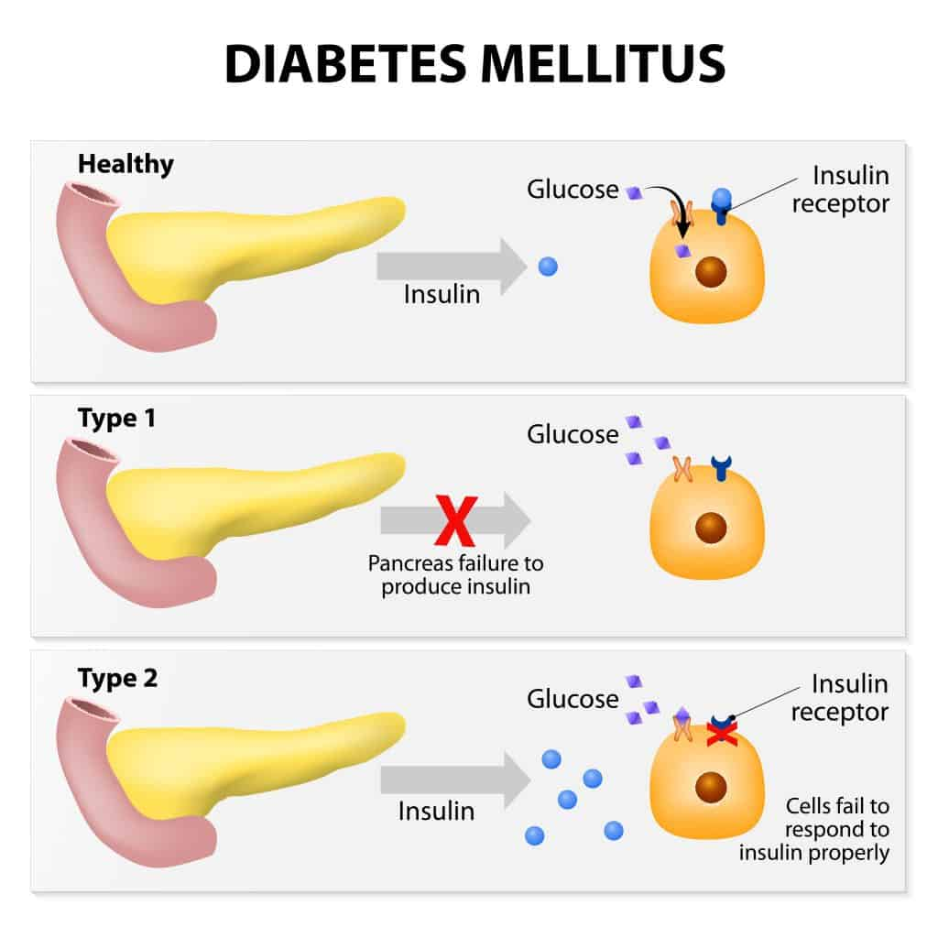  Figure 1: Diagram showing what happens in type 1 & diabetes
around the tummy/abdominal area. The body is very good at storing fat and will store some around the organs in the tummy or abdominal area. This is called visceral fat and can cause more health issues than the weight being carried elsewhere on the body.
This means that more insulin is needed to do the same job, like 2 keys being needed to unlock the cells instead of one. The body will be able to compensate for a time by producing more and more insulin and by trying to flush out extra sugar by making you feel thirsty, so you drink more and then pass urine more often. Individuals with undiagnosed or poorly controlled T2DM may also experience fatigue.
Other risk factors for T2DM include a family history, having polycystic ovary syndrome, fatty liver, previously having gestational diabetes, and there is emerging research that gout may make you more at risk, as these are all metabolic conditions.

How is it diagnosed?
T2DM is diagnosed from blood tests. People do not always have symptoms. The most common test is called a HbA1c and this gives an average of a person’s blood sugar levels over the last 3 months. It does not need to be fasted for. To confirm diabetes you need two tests with the HbA1c result of 48 or above. Other tests can be used if the HbA1c is not going to be accurate, such as in anaemia, recent blood transfusions or in pregnancy [for gestational diabetes].

What about medication treatments?
Over the years the management of diabetes has improved with many new medications to take by mouth and by injection available. Some of these can require you to take tablets twice daily, some need to be taken with/after food, or before food. Some medications mean you need to do home blood sugar checks with a meter (Figure 2) and can impact driving as a result. The aim of treatment of any condition is to keep the amount and strength of medications to the minimum required, as all medications have side effects. | 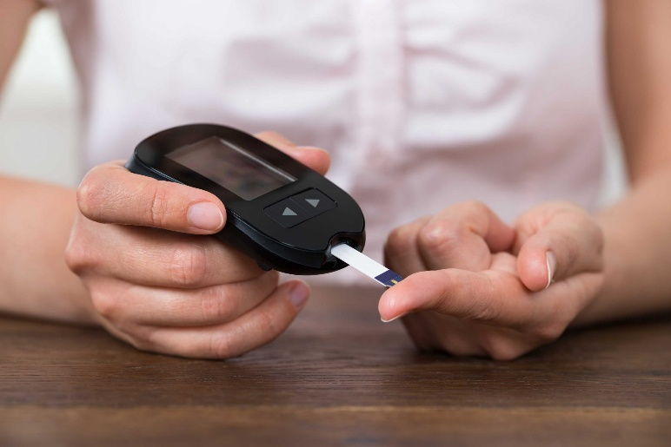  Figure 2: Home blood sugar meter
As we know diabetes can lead to many other health issues, once you have a diabetes diagnosis you will be monitored not only for the diabetes, but for your blood pressure, your cholesterol or lipids, your kidneys, your liver, your eyes (retinal annual screening service), so you often need to take additional medications to keep other conditions well managed. You will need to attend at least once a year to the treatment room for blood pressure, weight, blood and urine tests and then your results will be reviewed by our team. Some people need to be monitored more often. Most people with T2DM are managed at the surgery by our practice nurse Jane or by our advanced nurse practitioner, Katie Brown. Patients requiring insulin treatment are managed by the diabetes team based at Bangor Hospital.

Is it possible to ‘reverse’ T2DM?
Yes, it is possible to ‘reverse’ T2DM. We would actively encourage a ‘diabetes detour’. The sooner action is taken, the easier it is to reverse it.
Medications for diabetes are very helpful; however, diet and lifestyle changes can often provide impressive improvements in diabetes control, with people being able to put their T2DM into remission. T2DM remission has only been a concept for around the last 10 years, as it was always thought to be a progressive condition. Indeed, if no changes are made to diet and lifestyle then the condition will progress, and over time the number of medications required will increase, often to 3 or 4 different types with the average person requiring insulin by injection within around 10 years.
Weight loss can improve T2DM and other metabolic conditions, with just a 5% weight reduction showing better T2DM control. Diet plays a larger role in weight loss (approx. 80%) than exercise (approx. 20%). This is encouraging as not everyone can exercise. However, exercise doesn't require a gym membership; even short walks can significantly enhance overall health and mental well-being, especially if done outdoors.

What can I do to help my diabetes?
We now have more and more trials and information to show that T2DM can be helped if we reduce the amount of carbohydrates coming into the body. We have always known sugary foods and drinks are something the T2DM body will struggle to manage.
However, it is also the carbohydrates, e.g. bread, rice, potatoes, etc. - as these too will be broken down into sugar, like the sugary foods and drinks. The practice has been working with a charity to run a programme which supports patients with T2DM, and other related conditions, to make changes to their diet and lifestyle to improve their diabetes and other conditions (Figure 3).
The participants on our courses have reduced their medications for diabetes, blood pressure, cholesterol (lipids), heartburn, painkillers and gout. Here are their average results:
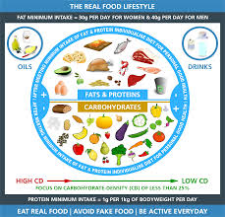  Figure 3: Public Health Collaboration real food lifestyle | - Diabetes improvement: HbA1c average reduction: 14mmol/mol, range of 3-31, for those with diabetes.  - Weight reduction: Average loss of 4.7kg or 5.7% of total weight. Range 2-11.5% and 1.4-11kg.  - Liver blood test: GGT (often a marker of fatty liver) reduction of 47.5% or 41 U/L.  - Mental health: Improvement in scoring of mood/anxiety on average of 48% and increased feelings of being better able to manage in 92% of participants.

Making changes to your way of eating is never easy and this is especially difficult when the rest of society is eating in another way, which is seen as the norm. This is compounded by often a lifetime, or many years, of eating a particular way. However, the important thing is to take it at your own pace and see it as a new way of eating, not a diet. T2DM does not develop overnight and changing your way of eating can take time to ensure you are doing it consistently. The participants who have been the most successful and managed to maintain their new way of eating on completion of the course, are the ones who have accepted it as a new way of eating and not a diet.

What about weight loss injections?
These medications (GLP1s) are already used for treatment of T2DM and have been around for more than 10 years. It is only recently they have gained a licence for a standalone treatment of obesity, making many people are interested in them. The current NICE guidelines allows them to be used for treatment of T2DM if 3 other medications, at their maximal doses, have ‘failed’ to achieve optimal control. The guidelines are in the process of being updated, so it might be that these medications are given permission to be used sooner.
However, these are not available for weight loss alone on the NHS in NI due to a lack of specialist clinics. Thinking of weight loss specifically, they are helpful, but trials show weight loss includes fat, muscle, and bone mass. Loss of muscle and bone is concerning, and when medication stops, two-thirds of the weight returns, with this weight being largely as fat, not the lost muscle or bone mass. This indicates the importance of addressing eating and lifestyle behaviours, rather than just symptoms. Unfortunately, there is no quick fix to weight loss/maintaining a healthy weight, as it is a multifaceted issue. There is growing evidence to suggest that there is a condition called food addiction. More information can be found on the Public Health Collaboration’s website.

Where can I find more information?
The practice’s real food group is running around twice yearly at the moment and lasts 10-weeks. If you are interested in taking part, there are application forms at both surgeries and planned to go on the website – please complete the form and return the paper copy to the surgery to be passed onto Katie Brown. However, you can go ahead and decide to change your way of eating and lifestyle via the resources below. The course we follow is available for free for people to access and implement at their own pace. If you choose to go ahead with this yourself, we would encourage you to link in with the online support groups, such as the ones listed below.

Useful links:
 | - Public Health Collaboration (PHC):  Charity who support a real food/low carb approach and provide support to the practice’s courses.  https://phcuk.org/
- Link to the PHC course:
A free 8-week course available on YouTube.

https://www.youtube.com/watch?v=Ll1OFEPfBCI

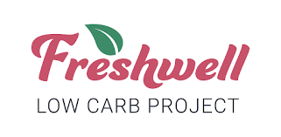   | - Freshwell Low Carb:  This was set up by 2 UK GPs in England to provide information to their patients and has expanded since then, including apps and Facebook support group  https://lowcarbfreshwell.com/
  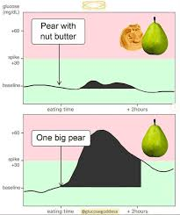 | - Glucose Goddess:  Jessie Inchauspé, also known as the Glucose Goddess, is a French biochemist who has tips on reducing glucose spikes, showing real world data from glucose sensors.  https://www.glucosegoddess.com/
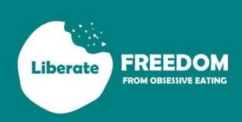 | - Liberate:  Liberate is an 8-week educational course with weekly support for the following 12 months. It was designed for those feeling addicted to ultra processed foods, using the biopsychosocial model of health.  https://liberatetoday.org/
Online support groups:
 | - PHC Real Food Lifestyle Support Group on Facebook  - Freshwell Low Carb Support Group on Facebook

CAUTION: Medications to be cautious of if starting a real food/low carb approach?
You are very welcome to complete the course in your own time, as the weekly videos are available on the Public Health Collaboration’s website. The only time this would be unsuitable is if you are taking any of the following medications:
-Gliclazide
-Glimepiride
-Any type of insulin.
In this case, you would need to do it with input from Katie Brown and with regular blood sugar monitoring, to ensure you do not get low readings, as your medication requirements reduce over the course.

If you are taking a medication called an SGLT2i, such as: Canagliflozin, Empagliflozin or Dapagliflozin, these medications need to be paused for the first 4 weeks after commencing a real food/low carb way of eating.

If you are taking a medication for your blood pressure or heart. You would need to obtain a home blood pressure monitor (from Amazon or a local pharmacy) and check your blood pressure on a twice daily (before breakfast and before evening meal) basis during the course. This is based on previous participants who have required their medication for blood pressure to be reduced or stopped completely all due to their diet and lifestyle changes. You would need to contact us if your blood pressure top reading (systolic) was consistently less than 115mmHg, as a general rule of thumb for most people taking BP medications. If you are under the Cardiology or heart failure teams, your blood may run lower than this.

If you are unsure or have any queries, arrange an appointment with Katie Brown, advanced nurse practitioner.

